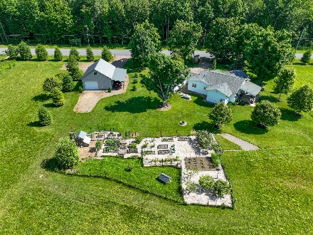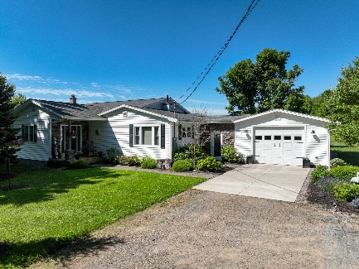

1888 Mulholland Road, Cleveland NY 13042
Home-
- 1894 Sqft (840 sqft original 1957, addition added on 1054 sqft in 2022)
- New roof shingles- designer- over whole house in (2022)
- Vinyl siding (2023)
- Veissman propane boiler, hot water baseboard, 2 zones with 2 Fujitsu mini-splits for heating and cooling (2023)
- R40 blown-in in ceiling
- 130’ deep drilled well, sediment whole house filter – new tank
- Back porch (covered) 19’x13’, treated lumber2 ceiling fans, 2 outlets overlooking 12 acres of field and pond
- Front porch (covered) 6’x10’ treated lumber, cultured stone wall, 2 outlets
- 2x6 walls and 2x10 floor joists in new addition
- 2x4 walls and 2x8 floor joists in original construction
- Crawl space (original), 4 ½’ ceiling, floor covered, walls insulated with 1” foam and boxes fully insulated with 1” foam and rockwod. 4 windows for ventilation, new part is foamed
- All gutter down spouts directed away from house
- Plumbing (copper) in original construction, Pex and copper in new construction
- All thermal windows, tilt for easy cleaning
- Cultured stone on walls of two entrance doors
- Ceiling fan lights in every room except bathrooms and kitchen
- 2 walk-in tile showers
- 2 freestanding stoves (soapstone-wood, cast iron propane)
- Vinyl and red oak flooring in original construction (newly refinished oak flooring)
- Vinyl and carpeting in new construction
- Wired smoke alarm system

Land-
- 60.48 acres surrounded by large wooded parcels
- Direct access to snowmobile trails
- Approximately 14 acres of fields
- ½ acre pond dug in 2017-stocked with bass, perch, pan fish, crappie and catfish
- Large fenced garden and small orchard, chicken coop and large pen
- Great hunting and trapping
- 1089’ of road frontage, 2412’ depth
- Ten minutes to Oneida Lake boat launch
- Forty minutes to Salmon fishing in Pulaski
- Eye appealing landscaping
- 4’x8’ hunting shed in back of property with up to 200’ shooting range
- Several food plots for deer and turkey
- Perimeter drain around 2 sides of house that drains into field
- Horseshoe pits
- 300 yard golf driving range in field
- Outside fire pit
- 130’ drilled well
- Conventional septic system with fiberglass tank, pumped in 2025

Garage – 17’x31’
Steel Barn – 26’x32’
- 10’ Ceiling
- Second floor- 2 level stairway
- Concrete floor with drain
- Attached lean-to 11x32’
- 2 Overhead doors 12’x16’ with openers
- Underground service from house
Old Barn – 65’x30’ Mostly concrete floor
Old hand dug well by road

